Thanks a million for your careful reading of this. I really appreciate it. I’ve tried to balance addressing your concerns with the constraints of (1) using existing / established method/materials; and (2) having the methods and materials already approved following peer review. I’m quite reluctant to deviate from the approved methods for fear that this would impact our in-principle acceptance.
1.
In the “How” instructions:
For example, like most people, you probably hope to find happiness in life. How can you do this? Perhaps finding a good job, or being educated, can help. How can you do these things? Perhaps by earning a college degree. How do you earn a college degree? By satisfying course requirements. How do you satisfy course requirements? In some cases, such as today, you participate in a psychology experiment.

In the “Why Instructions”:
For example, you currently are participating in a psychology experiment. Why are you doing this? Perhaps to satisfy a course requirement. Why are you satisfying the course requirement? Perhaps to pass a psychology course. Why pass the course? Perhaps because you want to earn a college degree. Why earn a college degree? Maybe because you want to find a good job, or because you want to educate yourself.

These instructions are tailored to university students. Is the key here to lead people to think about:
1. How their overall life goals lead them to doing this experiment today, and
2. How participating in this experiment today trace back to their overall life goals?
In that case, I would need to come up with a causal chain that works for general participants, correct?
Good catch. I took this wording directly from Freitas et al. (2004). My understanding is that the experiment is not particularly important, it is just used as an example to illustrate thinking about causal chains in general. It does read as more tailored to college students, but I think the use of “perhaps” in both is (hopefully) sufficient to allow non-students to see that “ok this specific causal chain doesn’t describe my experience, but if asked I could come up with an alternative chain that does, that is similar to the one described”.
So while not necessarily ideal for a non-student sample, the manipulation should still be effective if participants are able to see past the specific content of the preamble and focus on the relevant thought processes.

2. In the How Instructions:
This thought exercise is intended to focus your attention on how you do the things you do.
This sentence is a bit vague; I think we want people to think about how they achieve their goals, right? (e.g. how to gain happiness, how to maintain one’s physical health). Maintain one’s physical health seems not to be “a thing people do”.
I agree, but, as above, I’m reluctant to make a change. I think participants should be able to figure out what we're getting at.

3. For both the “How” and “Why” procedures, I was asked to list three ways to improve physical health or three reasons why I want to improve physical health. But on the next page, I am immediately asked to restate one of the ways/reasons. This made me confused because I was like “didn’t they just ask me that? Why are they asking me again? Did I read the previous instructions wrong, or am I reading the current instructions wrong?”
What is the reason for asking participants to list the three reasons on the first page? Why not immediately jump into the going upwards/downwards boxes?
Agreed, I thought it was a bit overkill while I was setting it up, but this is again taken from the original study. I’ve added an introduction to the task (this also addresses your point 7 below) that tells participants that first they’ll be asked to come up with three ways and second they’ll be asked to think of in more detail about 1 specific way/a particular goal

4. For going upward/downward boxes, my suggestion is: why not only show people the current box they need to fill in, instead of showing them all the boxes? For example, we could program it to make it look like the below: (I use the “why” condition as example)
I’ve done a hybrid of what you suggested and what was already there, and I think this is actually closer to the original (paper based) method.

Page 1
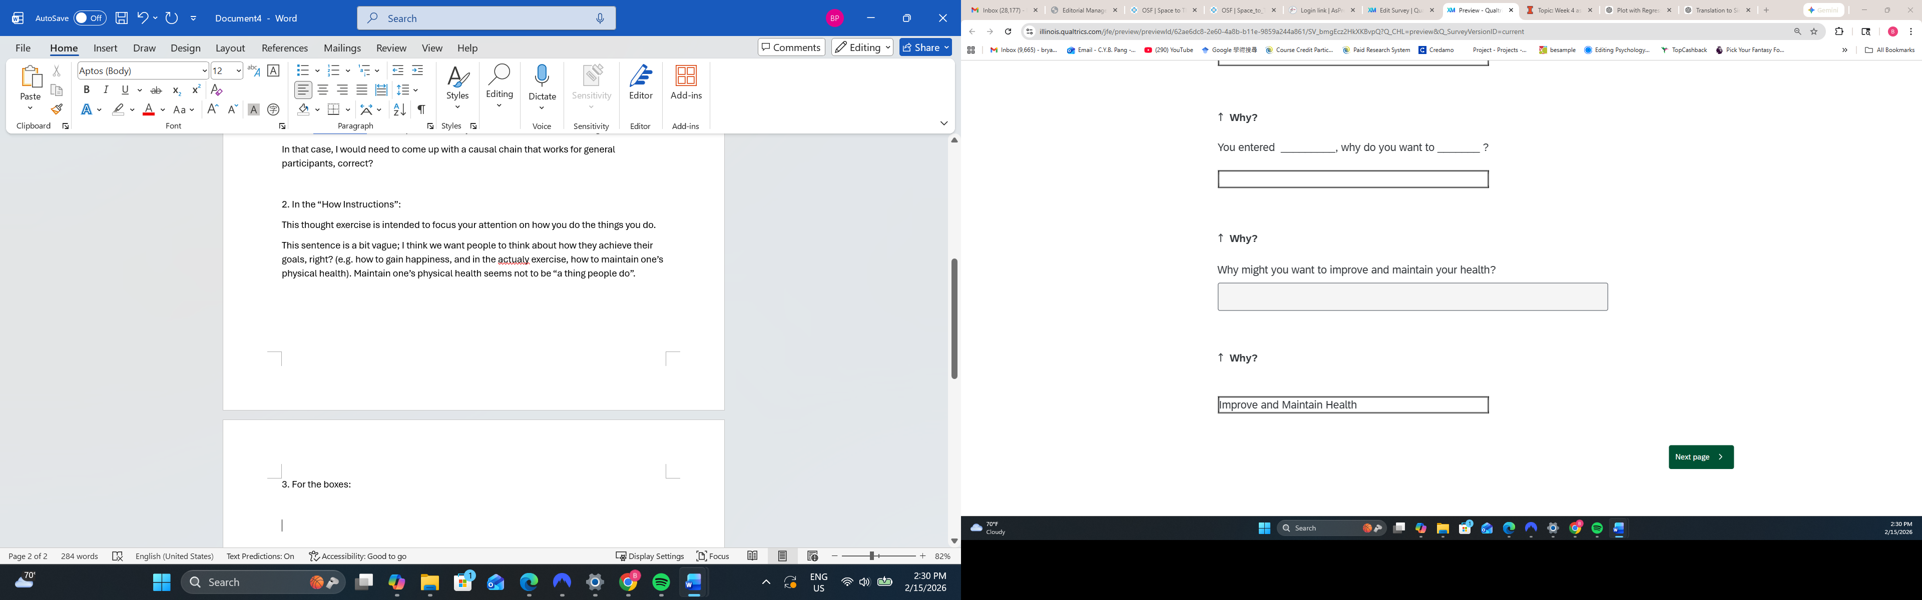
Page 2
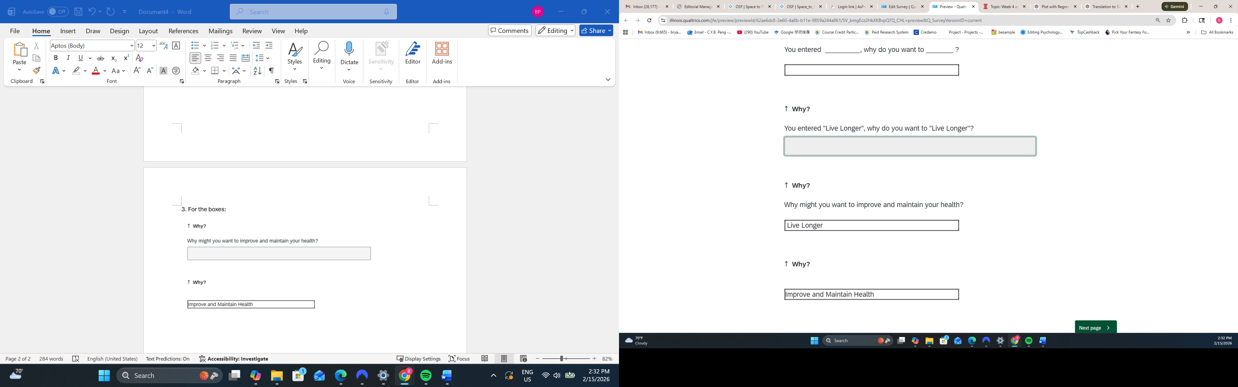

Page 3
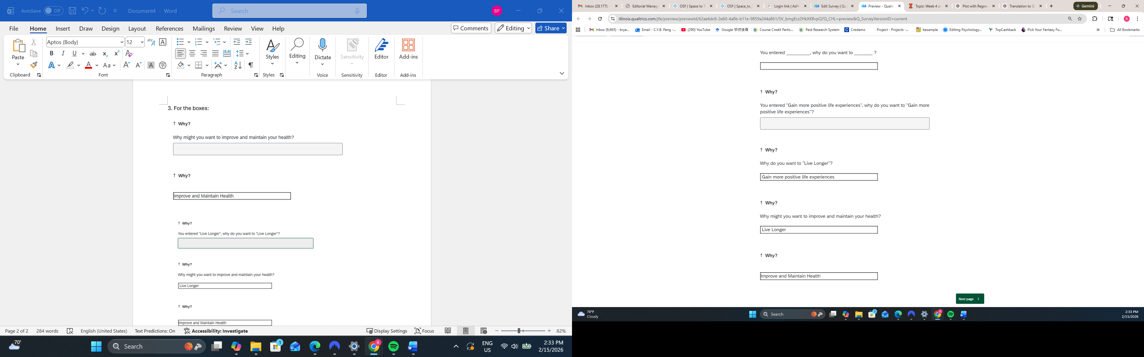
Page 4
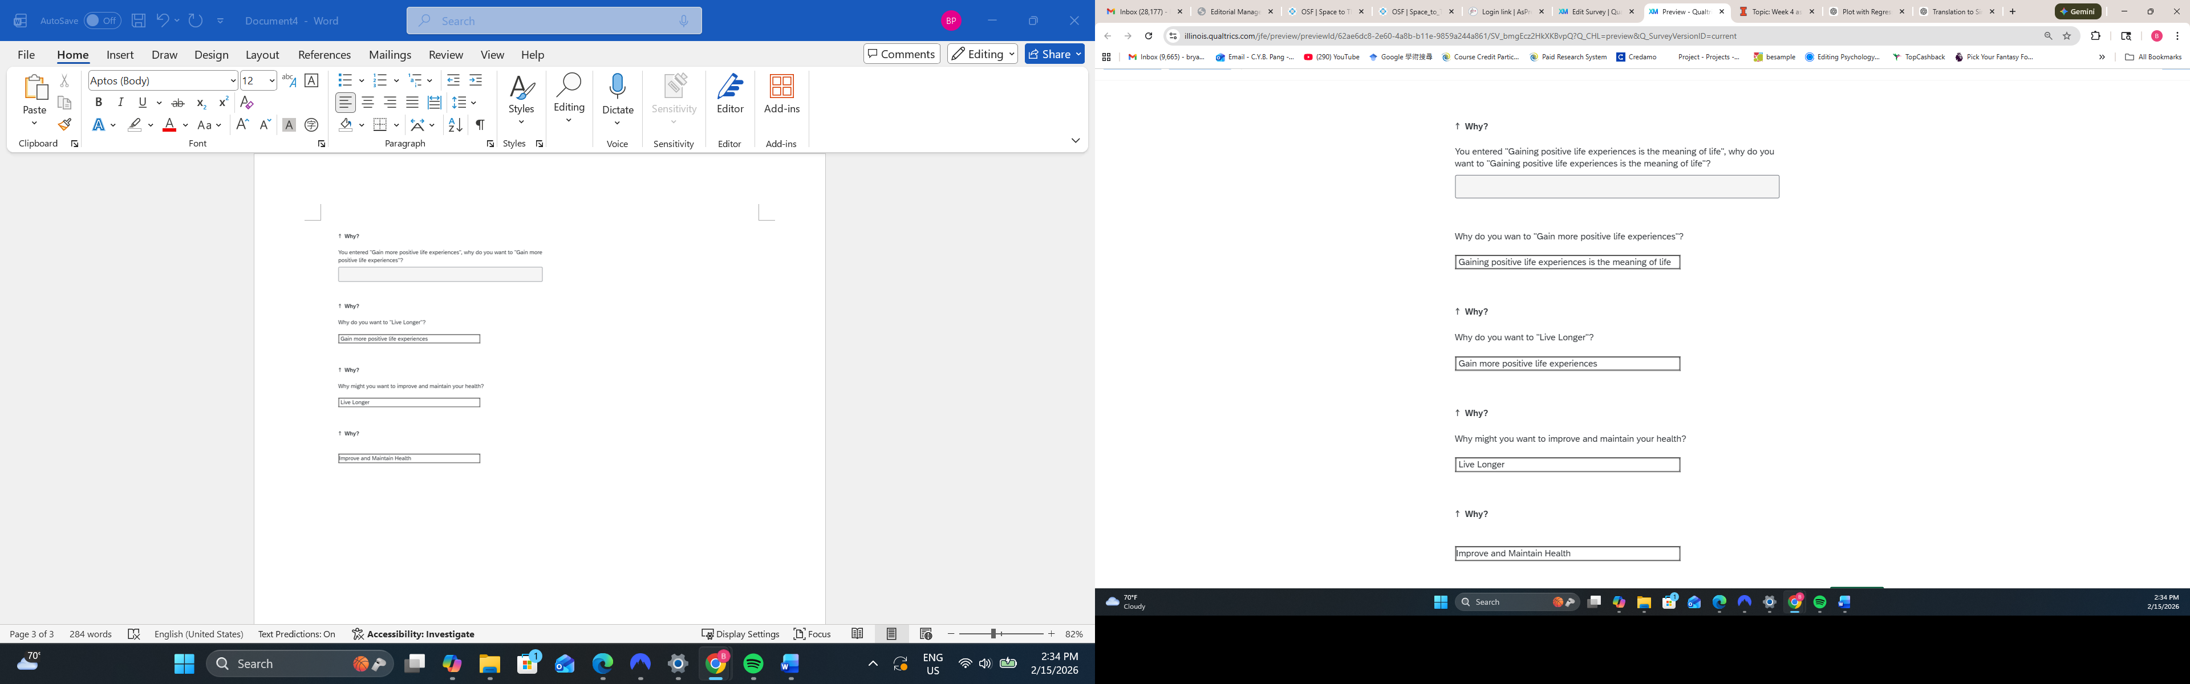
That might reduce participant confusion.

5. For the “Why” boxes, since the question asked is “Why do you want to XXX”, it is possible that people will key in something that is not an action. In which case, the next question won’t make sense.
For example, answering “Why do you want to gain more positive experiences”, I said “Gaining positive experiences is the meaning of life”. The next question, why do you want to gaining positive experiences is the meaning of life, doesn’t make sense.
It is also possible that to the first question,
Why might you want to improve and maintain your health?
One could answer: A healthy body is a key to happiness.
In that case, the chain is broken in the first step.

Maybe, you could add a “to _________” or “so that I could__________” in front of the box?
Why might you want to improve and maintain your health?
to ______________________
or
so that I could __________________________
In that case, people must enter an action. I have the java script to add words in front of text boxes; I can send over if you need them.
I found this also but I’m not sure how to address it. I hope that after the first “failed” answer participants will figure out a way to make it make sense. E.g., on your example “a healthy body is a key to happiness” they could infer this to be “happiness”. I’ve tweaked the wording of the prompt to read “you entered _______. Why do you want to achieve this?” I’ll note this as a deviation from the pre-reg in the revised submission, I think it’s sufficiently minor that nobody will object.

6. There is a bug in the “how” boxes:
Fixed (I hope)

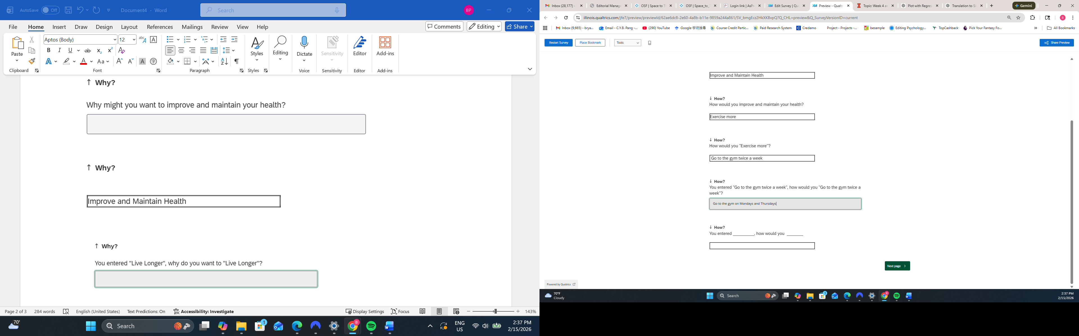
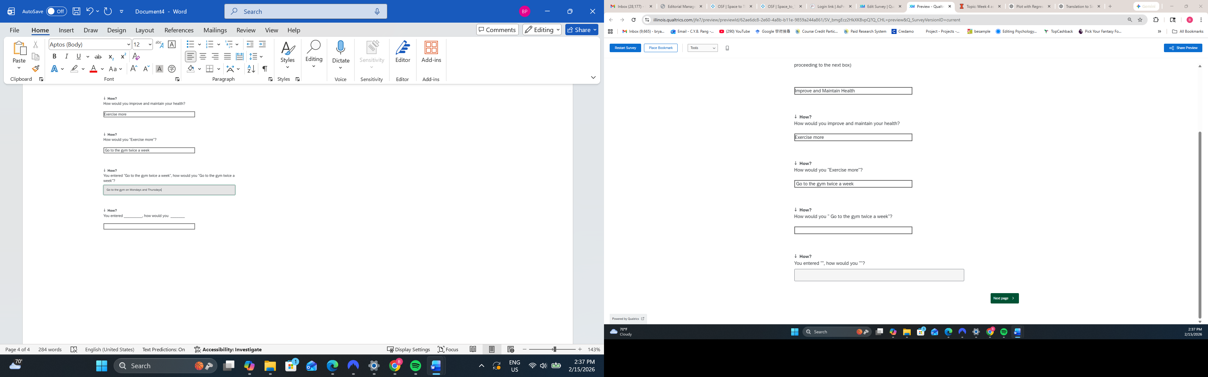
The last box doesn’t work (the thing I entered did not go on to the next page).
7. I found it a bit weird that in the consent form, I was told that this is a study on moral judgments. But the first part of the study is this unrelated exercise. And in the middle it jumped to moral judgments without transitions.
Maybe we need a cover story on why there are two seemingly unrelated parts to the study? Maybe in the consent form, say that we have two parts: one part about a thought exercise that improves well-being, and the second part about moral judgments?
Good call. I’ve added an “instructions” block for each task that notes “before you complete the moral judgment task….”

